**INSTITUTE OF ENGINEERING**

ADVANCED COLLEGE OF ENGINEERING AND MANAGEMENT

*(AFFILIATED TO TRIBHUWAN UNIVERSITY)*

[](https://acem.edu.np/)KALANKI , KATHMANDU

**TUTORIAL SHEET 3**

**SUBJECT: C PROGRAMMING**

**SUBMITTED BY: SUBMITTED TO: DEPARTMENT OF COMPUTER ENGINEERING**

SURYANSHU VERMA

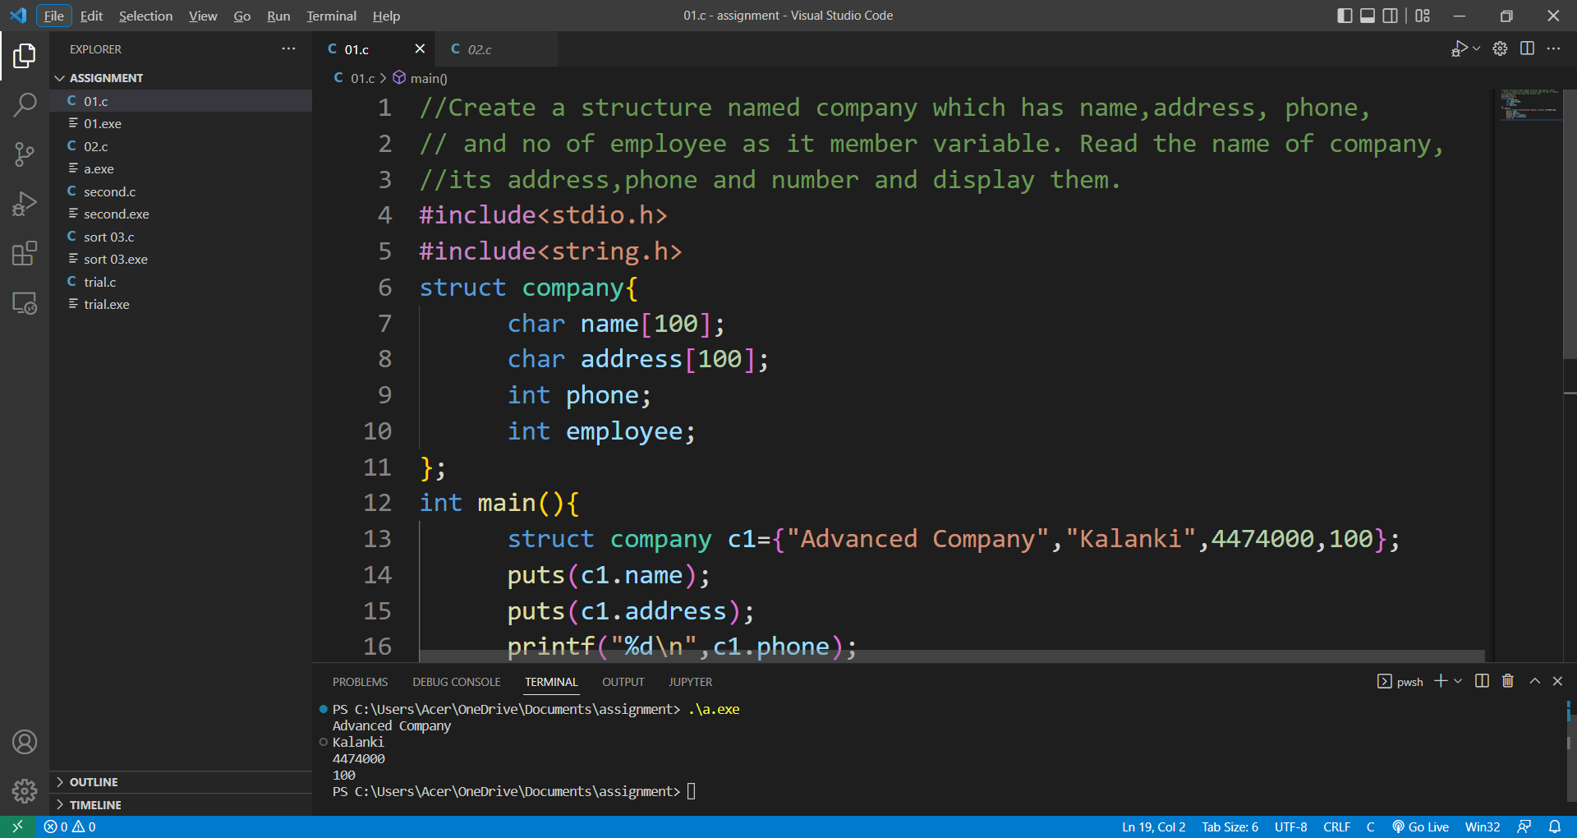

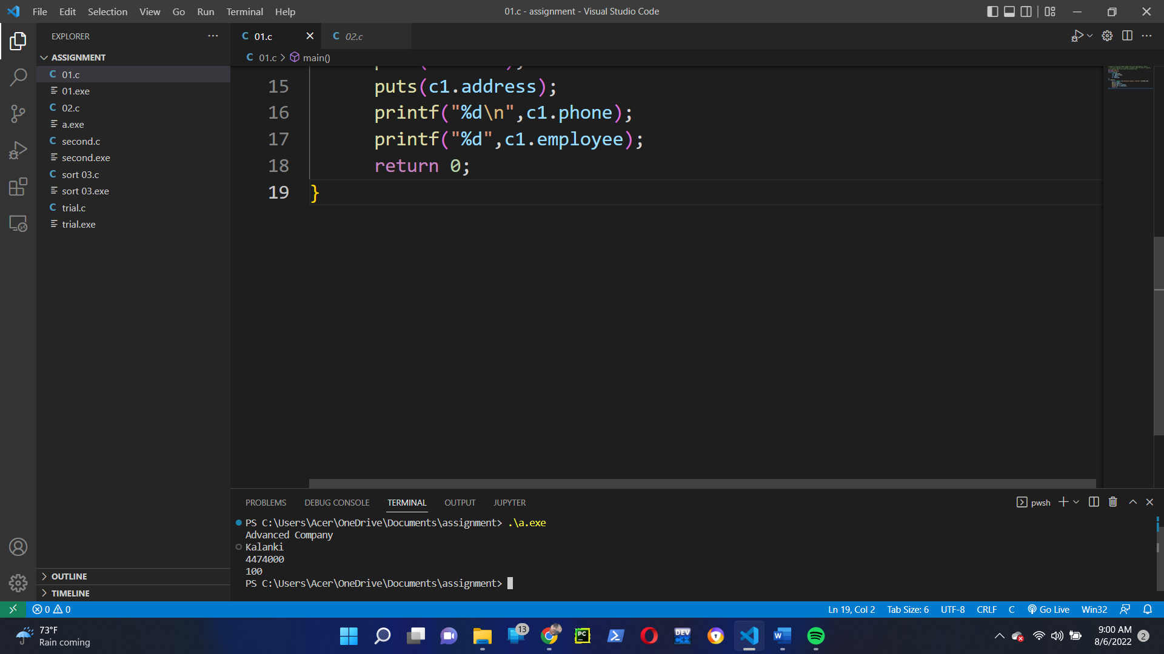

Q.N 2

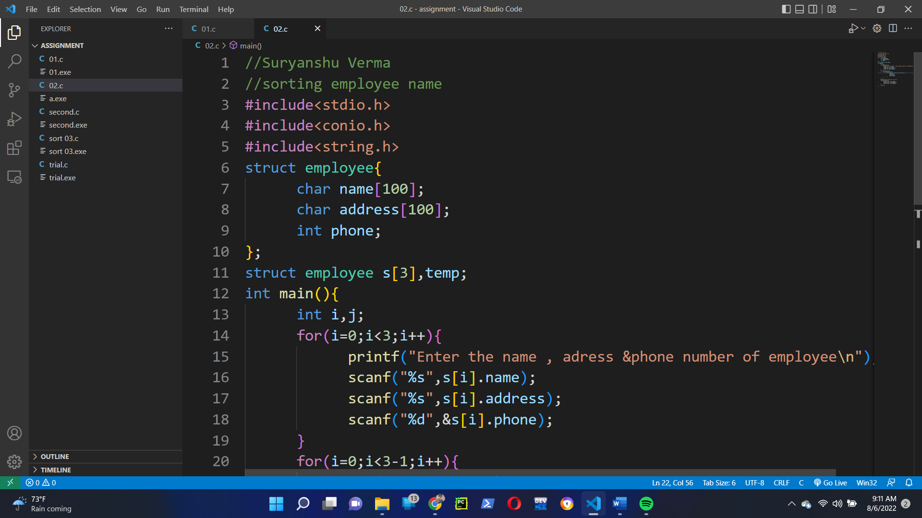

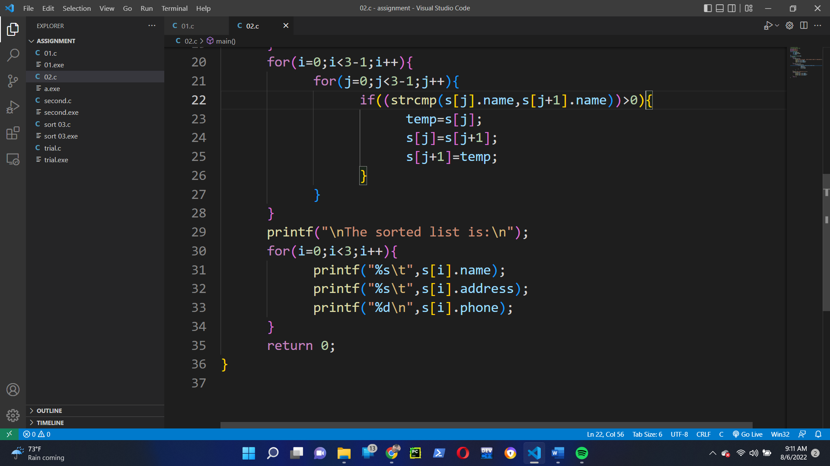

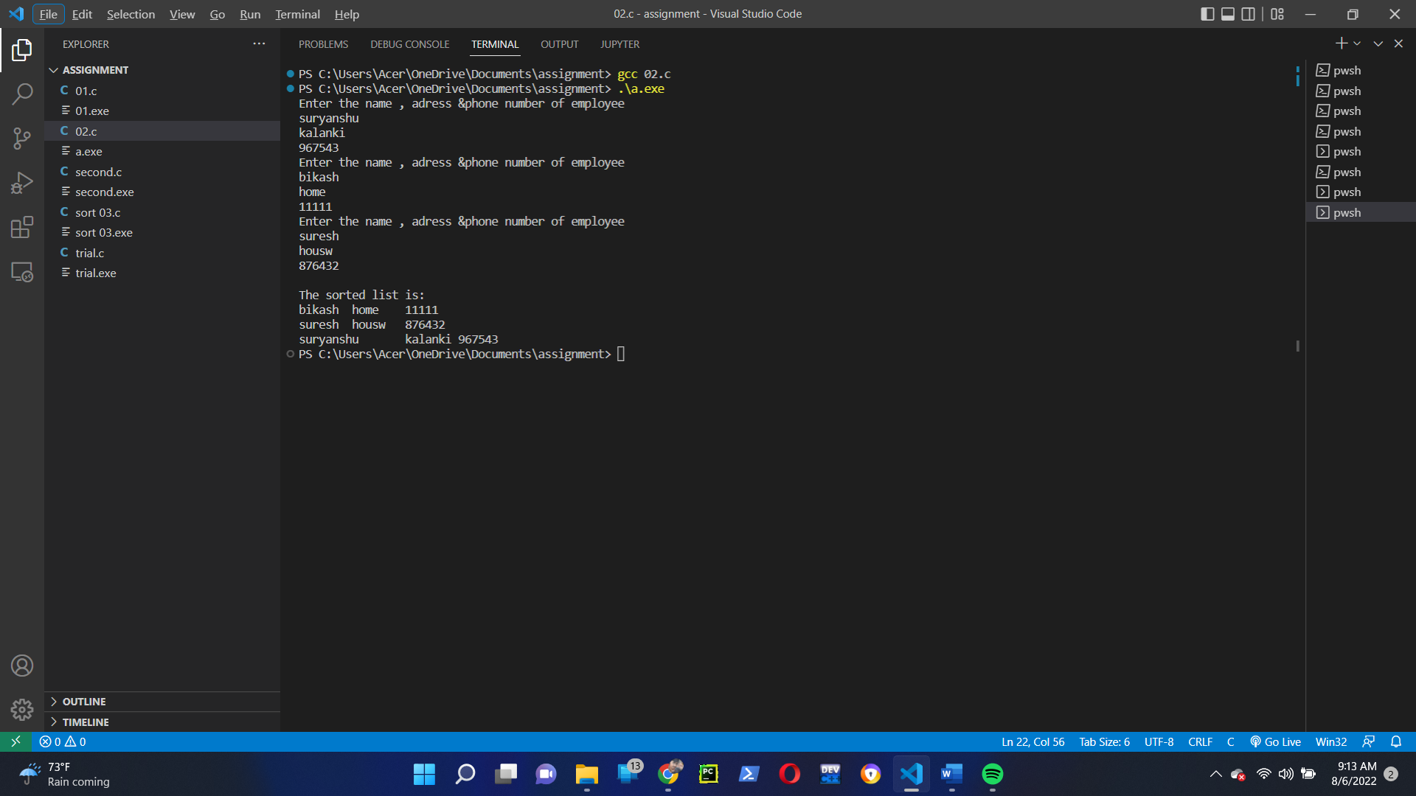

Q. No 3

